Critical Analysis of   
Eradication of Poverty in India: Impact of Financial Inclusion

short line

Group 6:

Namit Agrawal (18B080018)

Sharang Mantri (18B080022)

Sneh Jagwani (170110047)

30th March, 2021

# Table of Contents

**Abstract**  **2**

**Introduction** **Error! Bookmark not defined.**

**Literature Review**3

**Data and Methodology**9

**Limitations of Study**12

**Analysis**13

**Progress post PMJDY and implications on poverty**17

**Conclusion**21

**Appendix**22

# Table of Figures

**Fig 1: Summary statistics of the variables 11**

**Fig 2: Correlation between variables 12**

**Fig 3: Regression results of the proposed models 13**

**Fig 4: Fitted value graph of lnpov vs financial inclusion index 2011 14**

**Fig 5: State-wise level of financial inclusion with respect to branch penetration** **1****5**

**Fig 6: State-wise level of financial inclusion with respect to deposit penetration** **1****6**

**Fig 7: State-wise level of financial inclusion with respect to credit penetration 16**

**Fig 8: Region wise score of inclusion parameters (CRISIL Inclusix, Feb 2018, Vol 4) 17**

**Fig 9: Yearly growth in deposit accounts (CRISIL Inclusix, Feb 2018, Vol 4) 18**

**Fig 10: Number of accounts by type (CRISIL Inclusix, Feb 2018, Vol 4) 19**

**Fig 11: Growth in banking service across regions in fiscal 2016 (CRISIL Inclusix, Feb 2018) 19**

**Fig 12: Growth in MFI Branches (CRISIL Inclusix, Feb 2018, Vol 4) 20**

**Fig 13: Growth in bank branches (CRISIL Inclusix, Feb 2018, Vol 4) 20**

# Abstract

Our study analyzes the state-level poverty and financial inclusion data to examine the impact of financial inclusion on poverty alleviation. Our study proves that financial inclusion is an important factor in our fight against poverty. Further, our study analyzes the impact of Pradhan Mantri Jan-Dhan Yojana (PMJDY) on financial inclusion. Our study provides 2 main recommendations. The push needs to have regional-level objectives and policy to ensure all regions have equal access to financial services. Further the government needs to work on improving other metrics of financial inclusion like credit penetration, insurance cover to ensure poor get the maximum benefit of financial inclusion.

# Introduction

Why is poverty eradication an important issue for any country? If we look into the bare minimum needs for human survival, poverty not only deprives the people of economic or material resources, it is also the cause for the violation of internationally recognized human rights. These rights can be economic and social such as the right to health, adequate housing, food and safe water, and the right to education or the civil and political such as the right to a fair trial, political participation, and security of a person. Even though the right to be free from poverty has not been recognized as a legal human right because of the reluctance of the governments to accept the legal responsibility, the Vienna declaration has characterized extreme poverty as the violation of human dignity which is the core of all human rights[1]. Thus poverty eradication becomes an important issue for a country’s government as it leads to the recognition of citizens’ dignity and furthermore, ensures the acknowledgment of other human rights.

From an economic point of view, the relationship between poverty and growth is not direct. But since poverty is mainly defined as a lack of economic resources, we look into all possible correlations for this case. According to Kuznets’ curve, as an economy develops, the market forces first increase the inequality and then decrease it. In this case, the goal of economic growth along with poverty alleviation would only align, if we knew the position of our economy on the Kruznet’s curve. Since there is a possibility that poverty eradication might lead to economic growth or vice versa, we explore the rationale that would make this possible. At an individual level, a better standard of living with basic necessities like food, shelter, health, and education would facilitate the enhancement of individual productive capacities and in turn, would add up to the country’s productive capacity which is crucial for economic growth. An overall increase in per capita income would lead to more savings and hence, more investments which could be helpful in boosting the economy. In addition, skill development and the development of technical know-how through education would incentivize technological development and therefore have a sustainable path towards development.

Now that the world is moving towards a broader view of development through the action for sustainable development goals by the United Nations, poverty eradication is one of the 17 goals to achieve a peaceful and prosperous society. Therefore, poverty eradication is a major issue for developing countries like India and the path to the stated goal seems to be tedious because of the lack of a clear correlation of policy instruments with poverty.

In the next section, we look into historical origins of poverty in our country and review the literature on other major policies that have been implemented in this regard.

# Literature Review

## Pre-Independence Period

We review Maddison’s analysis of the historical origin of poverty in India[2]. By taking this paper, we do not intend to say that 200 years of oppression was necessary to bring development and the British did not loot enough wealth from the country to push the country into poverty, but apart from that there were many structural constraints of the society due to which people were poor in the pre-colonial or during the colonial period. These structural constraints might still exist in today’s society and hence, it is necessary to discuss them as we aim towards poverty eradication.

In the Mughal Indian economy, the basis of economic life was a Hindu village, which were considered as self-contained units designed for survival in wars or alien domination. These units were marked by rigid hereditary groups whose economic and social functions were clearly identified. Land taxes were collectively paid, the upper class collected the taxes from the peasants, kept a part for themselves and the rest was paid to the central power. Since the upper class had no roots in the production process, there was no incentive for them to increase the productivity and the peasants had little resources to do that. Moreover, as most of the people lived in joint families where the incomes were pooled, there was no individual incentive to work or save and the rigid caste division of labor further prevented that. As Mughal need of luxury items increased, urban centers for the production of fine cotton and silk textiles, jewelry, decorative swords and weapons. So, the export items for India were mainly luxury textiles, saltpetre, indigo, sugar, opium and ginger and the import items were limited to precious metals, wollens, metals as India had little taste for European goods. This led to limited capacity for foreigners to buy Indian goods as they could only pay by precious metals and the exports of India were restricted to 2% of the GNP.

After the collapse of Mughal empire and continuous warfare, the economy weakened and internal trading was hampered due to local transit costs. The coming of the East India company led to the transfer of wealth from Indians to British officials through tax revenue. The civil servants were of the utilitarian mindset and abhorred the state interference for economic development. Hence, the state apparatus was more of a watchdog character with a few development ambitions. They started promoting western school of thoughts by abolishing practices like Sati, slavery and eliminated dacoits from the highway. But the mutiny of 1857 caused the British to stop taking over new territory and therefore, nothing was done to break the many traditional obstacles against development. They included fatalistic asceticism, the preference of magic rather than science, the maintenance of enormous number of cows with low productivity, debilitating vegetarianism, insanitary habits with regard of washing and sewage as that was the considered for lower castes, refusal to kill rats and pests as it was taken as a sin, wasteful ceremony and marriage fests, and the low status of women. The British gave up. Apart from building railways and canals, they did almost nothing to promote economic development.

The tax burdens by the British were lower than the Mughals. The chief effect of this was to increase the income of the landlords in Bengal and other areas of Zamindar settlement and in other areas, the benefits were accrued to the peasants. The gains of the peasantry probably went to increase the population rather than per capita income. Hence, when India became independent, its tax base was very low and there was probably a larger proportion of poor peasants and landless labourers in the population than there had been under the Mughals. Indian nationalists accused the British for overtaxing and reduced the taxes instead of using high taxes for development like Japan. The burden form the British rule was the flow of high income into the hands of foreigners and hence, transferring the purchasing power to someone with foreign taste of goods, increasing imports and damaging luxury handicraft industries. Potential savings for potential economic growth were siphoned abroad.

The British policy of segregating Indians from positions of responsibility and power greatly weakened the entrepreneurial dynamism which western influence and foreign trade might have introduced. The early monopolistic position of the East India Company meant that a good deal of the most lucrative commercial, financial, business, and plantation opportunities were absorbed by foreigners. The basic limitations on the growth of industrial output in India were the extreme poverty of the local population, the fact that a large proportion of the elite had a taste for imported goods or exported their purchasing power, the fact that there was no tariff protection, or government preference for local products. The banking system gave little help to the industry and technical education was poor. In Japan the government promoted industrialisation by setting up State industry on an experimental basis and then selling off the plants to private enterprise. The development of railways did not do much good to the country as compared to other countries.

## Post-Independence to Pre Liberalisation Period

India during the post-independence to pre liberalization period saw a very slow growth rate as to what was expected to eradicate poverty in the country

India's post-independence five-year plans were created with the hope that the country's urban-centred industrialisation process would bring longer-term gains to poor people, including through rural labour absorption thus will help in the reduction of widespread poverty.

The plan was largely shattered by the slow pace of poverty reduction in the period from Independence until the 1980s due to the slow pace of labour absorption from agriculture associated with the more inward-looking and capital-intensive development path of this period.

It can also be viewed that too little growth was the reason for India’s slow pace of poverty reduction, but the exploration of the data suggests that the sectoral pattern of growth also played a role.

Using data up to the early 1990s, Ravallion and Datt (1996) and Surjit S. Bhalla (2003) found that rural economic growth was more poverty-reducing, as was growth in the tertiary and primary sectors relative to the secondary sector. They also found that spillover effects across sectors reinforced the importance of rural economic growth to national poverty reduction. Urban growth and secondary sector growth had adverse distributional effects that mitigated the gains to the urban poor, while urban growth brought little or no benefit to the rural poor. The slow progress against poverty reflected both a lack of overall growth and a sectoral pattern of growth that did not favour poor people.

Various efforts were made post-independence including land redistribution, wealth redistribution for the reduction of poverty but due to various loopholes, such efforts were not implemented properly in most states thus contributing very less than expected in poverty reduction.

From the 1950s to the 1970s the percentage of people below the poverty line remained almost the same as viewed mainly to the low growth rate and lack of proper implementation of poverty reduction policies during the period with an increase in the percentage of people below the poverty line during the first and third five-year plan period.

The economy grew at an average rate of 3.5% per annum during this period, placing India in the bottom quintile of the global growth ranking and proportion of people below the poverty line, the Head Count Ratio (HCR), increased by an average of 0.2 per cent point per annum during this period.

The economy grew at a much better rate during the mid 70s to 1990 compared to the earlier post-independence era mainly due to the Green Revolution and gradual opening up of the economy during this period which led to a higher reduction in poverty compared to the time period of 1950- 1970 though still very less compared to post-liberalization period.

The GDP growth rate during this period was averaging 5.8% per annum with the coefficient of variation (CV) in the growth rate declined to 0.3, one-third of its earlier value. This was primarily because of a decline in the CV of agriculture which in turn was driven by a decline in the CV of rainfall mainly due to the onset of the Green Revolution. The rate of growth of Per capita GDP almost tripled to 3.7% per annum compared to 1950-1970 as well as there was an acceleration in the rate of growth of private consumption.

As a consequence of this higher growth rate of income and consumption, the proportion of the population below the poverty line (HCR) declined by 0.8 per cent point per annum during this period.

For the conclusion of the period between 1950 - 1990, we can say that post-independence political and administrative leadership was highly motivated, educated and honest and despite its sincere efforts to develop India and rid it of the scourge of poverty, the proportion of citizens below the poverty increased. Despite drawing on the best development economists in the world and pioneering the concept of mixed economy and non-communist socialism, development performance as measured by the rate of per capita income was extremely poor compared to other countries, though problem lay in the policy regime saw a great improvement in the performance during the phase of the 1970s - 1990 due to better policy implementation like Green Revolution, gradual opening up of the economy and due to rise of more number educated people driven with agenda to increase the growth rate of India and reduce the poverty in the country.

## Post-Liberalisation Period

Post-1991, the liberalization reforms were hailed as a way to sustain high growth which would reduce poverty. Petia Topalova (2005) discusses the evidence for the same. Using a difference-in-difference approach, he establishes that In rural districts where industries more exposed to liberalization were concentrated, poverty incidence and depth decreased by less as a result of trade liberalization, a setback of about 15% of India's progress in poverty reduction over the 1990s. (He attributes this result to the limited mobility of factors across regions and industries in India. He suggests that additional policies may be needed to redistribute some of the gains of liberalization from winners to those who do not benefit as much)

A major push towards poverty alleviation was Mahatma Gandhi National Rural Employment Guarantee Act 2005 (MGNREGA). P Mahendra Varman and Neeraj Kumar’s study indicate an increase in the monthly per capita consumption expenditure of participant households and a change in their consumption patterns with the share of high-value and nutrient-rich food in their consumption basket going up. Further, the participant households have also smoothened their consumption by investing in assets such as durable goods. In another study, Shamika Ravi and Monika Engler analyze the impact of India’s National Rural Employment Guarantee Act (NREGA) on poor rural households. Their results indicate that the NREGS significantly increased the monthly per capita expenditure on food and non-food consumables. The program also improved food security by a significant reduction in the number of meals foregone by households per week. The program raised the probability of holding savings and reduced the incidence of depression among rural households.

An issue that has emerged in recent years is the issue of urban poverty. There are multiple differences between urban and rural poverty. The urban poor lacks adequate housing and basic services. In cities, the poor get pushed into slums or informal housing. Here, the urban poor get squeezed into single rooms that are grossly inadequate for a family to live in. Since such shelter is mostly unauthorized and built without permission, slum dwellers could be evicted at any time. To add to the misery, the urban poor are also much more deprived in the areas of sanitation and infrastructure. The non-availability of toilet facilities, especially for women; lack of drinking water, clean air and ventilation; and exposure to disease make living conditions awfully run-down. There are other dangers and challenges lurking — challenges of transport, the dangers of extortion, and increased vulnerability to crime. It is not difficult to imagine what kind of family relationships and human values will get nurtured in such a disparaging environment.

The stark differences that are seen in the living standards of the urban rich and the urban poor have a significant bearing on the psychology of the urban poor. Within the rural society, the standards of living of all village folk across the economic spectrum are far less stratified than in cities. As a consequence, relative poverty is a less conspicuous term in a village on account of an almost enforced standardization of quality of life in many villages. The situation breeds powerlessness, emotive confusion, resentment, and buried anger. These differences escalate as cities become larger and worsen the cited characteristics of poverty.

One of the policy objectives that has got a significant push is financial inclusion especially through the Pradhan Mantri Jan-Dhan Yojana to ensure access to financial services, namely, basic savings & deposit accounts, remittance, credit, insurance, pension in an affordable manner.

The benefits provided under PMJDY are:

* One basic savings bank account is opened for unbanked person
* There is no requirement to maintain any minimum balance in PMJDY accounts
* Interest is earned on the deposit in PMJDY accounts
* Rupay Debit card is provided to PMJDY account holders
* Accident Insurance Cover of Rs.1 lakh (enhanced to Rs. 2 lakh to new PMJDY accounts opened after 28.8.2018) is available with RuPay card issued to the PMJDY account holders
* An overdraft (OD) facility up to Rs. 10,000 to eligible account holders is available
* PMJDY accounts are eligible for Direct Benefit Transfer (DBT), Pradhan Mantri Jeevan Jyoti Bima Yojana (PMJJBY), Pradhan Mantri Suraksha Bima Yojana (PMSBY), Atal Pension Yojana (APY), Micro Units Development & Refinance Agency Bank (MUDRA) scheme

The RBI has also taken several measures to augment financial inclusion. Based on the new guidelines on differentiated banking licences for small banks and payments banks, approvals for 10 small finance banks were issued. Most of them have commenced operations. Besides, the RBI has been emphasising on financial literacy through its bank networks, complementing business correspondents with technology and actively exploring alternate delivery channels to further the financial inclusion cause. Adoption of Aadhaar and Aadhaar-based identification will also help improve financial inclusion.

FInancial inclusion is essential for achieving the twin goals of growth and equity in the economy. To understand the various mechanisms in play, we need to look into the informal credit providers available to the poor. These moneylenders tend to have high interest rates making it difficult to repay for the poor. This can also lead to poor people taking loans to repay earlier loans which puts them into a debt trap. The mechanisms to collect payments are often exploitative. Given the initial wealth inequality in many developing economies, access to banks is essential to provide credit for entrepreneurship which is essential for growth. It can also provide access to financial products like insurance which is needed to mitigate the risks which can put lower class into poverty. A common example is failure of crops leading to loss of income which pushes people into poverty or debt traps. As income grows, it also leads to better utilization of savings as they get access to multiple investment products leading to more secure long term income, preventing people falling into poverty even after any risks like we discussed before materialized. The policy has also got backlash from opposition as they claimed that it has created unnecessary workload for public sector banks and led to duplicate accounts and other complications. Given the large costs involved to meet this policy objective, it is imperative to understand the empirical analysis to back the theoretical benefits discussed above.

A major study was done on financial inclusion by Md Abdullah Omar and Kazuo Inaba using panel data of 116 developing countries from a period of 2004-2016. The results provide robust evidence that financial inclusion significantly reduces poverty rates and income inequality in developing countries. The findings are in favor of further promoting access to and usage of formal financial services by marginalized segments of the population in order to maximize society’s overall welfare. Swamy (2014)[3] found that gender dimension, particularly poor women’s participation in financial inclusion programs in general, had a strong impact on increasing household income and improving family well-being in India. Burgess and Pande (2005)[4] revealed that state-led bank branch expansions into rural unbanked locations significantly reduced rural poverty in India through access to formal sector credit provision and saving opportunities. Brune et al. (2011)[5] determined that increased financial access by offering commitment savings accounts to poor smallholder cash-crop farmers in Malawi had a substantial impact.

Past research done in the Indian context lacks a robust index for financial inclusion that takes into account the multiple dimensions of financial inclusion: branch penetration, credit penetration and deposit penetration. Thus previous studies are limited to analysis of programs like state-led branch expansions in rural areas and social experiments to determine impact of savings accounts. Presence of such a financial index now has allowed us to measure the impact of financial inclusion in the indian context through more robust analysis.

# Data and Methodology

We use the following baseline regression equation to investigate if the level of financial inclusion is related to poverty by taking the data for 34 Indian states and Union territories.

$$lnpovhead_{i}^{} = α+ β_{1}cfii_{i }+β_{2}gsdpgr_{i}+ β_{3}lngsdppc_{i }+{ β}_{4}lngini_{i }+ β_{5}lnssenroll_{i }+ β_{6}lnsocexp_{i } + u$$

Where lnpovhead = log of poverty headcount, cfii = Crisil Inclusix financial index, gsdpgr = growth rate of GSDP, lngsdppc = log of per capita GSDP, lngini = log of (rural or urban) gini coefficient, lnugini = log of urban gini coefficient, lnssenroll = log of secondary school enrollment ratio, lninflation = log of inflation, lnsocexp = log of social sector expenditure.

The data for poverty headcount is obtained from the RBI publication on the number and percentage of population below the poverty line dated on Sep 16, 2015[6]. The numbers are for the year 2011-12 and represent the percentage of persons below the poverty line. This is our dependent variable in the regression with no missing values for 27 states and 8 union territories of India.

The index for financial inclusion is developed by CRISIL, an Indian analytical company, supported by the ministry of finance, Govt. of India, and the RBI. CRISIL defines financial inclusion as “The extent of access by all sections of society to formal financial services such as credit, deposit, insurance and pension services.”[7] It is calculated on the basis of 3 parameters that are branch penetration (BP), deposit penetration (DP), and credit penetration (CP). A CRISIL Inclusix of 100 indicates the ideal state for each of the three parameters. The premise of this correlation is that financial inclusion plays an important role in economic and social development. So, we expect the coefficient of cfii to be negative as higher financial inclusion would help in reducing poverty.

The next dependent variables are GSDP growth rate and GSDP per capita (in INR at constant 2011-12 prices). The data source for them is a state-wise data report by the Economic and Statistical Organization, Govt. of Punjab dated on Feb 05, 2021[8]. This correlation is based on the trickle down effect of economic growth. As the income per capita increases, it is expected that the gains would reach to the bottom pyramid of the society as well, and hence the coefficient for GSDP per capita should be negative. On the contrary, as the growth rate of an economy increases, it is highly possible that the only better-off section of the society is focussed as they constitute higher share in the economic activity, and therefore it might lead to an increase in the poverty headcount. The data for 3 union territories is missing in this case, so if they do not have data for other variables as well, we will exclude them from our analysis.

The rural and urban Gini coefficient work on the fact that higher income inequality favors the non-poor and hence, the correlation is expected to be positive. The effect on rural poor and urban poor can be differentiated with the magnitudes of the coefficients. The data for these variables are sourced from planning commission estimates using data from the 66th round of NSSO sample surveys[9]. The variable for secondary education represents higher levels of education leading to improvement in skills and knowledge which could furthermore improve the income levels. Therefore, the coefficient must be negative. The department of school education and literacy under the ministry of human resource development brings out educational statistics regarding our concerned variable[10].

As government involvement is a major factor in poverty eradication, we include an independent variable social sector expenditure (in INR crores). Development in the social sector leads to an increase in capabilities of people, equipping them with enhanced labor productivity. This indicates that with increasing social expenditure from the government, the poverty headcount should decrease leading to a negative correlation. We have sourced the data from the RBI’s handbook on Indian Statistics[11].

We also take zonal councils into account for our analysis. This is done to ensure that we acknowledge the possible groupings in our sample before generalizing the results. Zonal Councils are advisory councils and are made up of the states of India that have been grouped into five zones to foster cooperation among them. These were set up with Part-III of the States Reorganisation Act, 1956. The present composition of each of these Zonal Councils is as under:

* The Northern Zonal Council, comprising the States of Haryana, Himachal Pradesh, Jammu & Kashmir, Punjab, Rajasthan, National Capital Territory of Delhi and Union Territory of Chandigarh;
* The Central Zonal Council, comprising the States of Chhattisgarh, Uttarakhand, Uttar Pradesh and Madhya Pradesh;
* The Eastern Zonal Council, comprising the States of Bihar, Jharkhand, Orissa, and West Bengal;
* The Western Zonal Council, comprising the States of Goa, Gujarat, Maharashtra and the Union Territories of Daman & Diu and Dadra & Nagar Haveli;
* The Southern Zonal Council, comprising the States of Andhra Pradesh, Karnataka, Kerala, Tamil Nadu and the Union Territory of Puducherry.
* North Eastern Council, comprising of (i) Assam (ii) Arunachal Pradesh (iii) Manipur (iv) Tripura (v) Mizoram (vi) Meghalaya and (vii) Nagaland viii) Sikkim (set up under the North Eastern Council Act, 1972. The State of Sikkim has also been included in the North Eastern Council vide North Eastern Council (Amendment) Act, 2002 notified on 23rd December 2002)

**Fig 1:** *Summary Statistics of the variables* 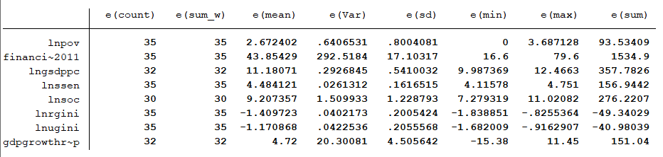

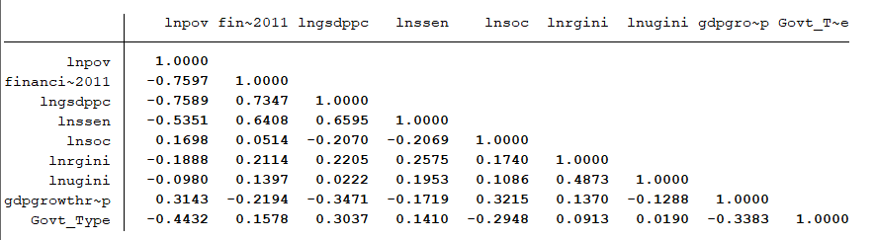

**Fig 2:** *Correlation between the variables*

# Limitations of Study

Despite our attempt to make the study as robust and comprehensive as possible, the limitation imposed by quality and quantity of data could contaminate the results. Some of these limitations are stated below:-

* Small dataset

We selected the year 2011-12 as it was the NSS survey and the last year for which state-wise poverty rates are available. A comprehensive and robust financial inclusion index was not available for years before 2011. The study could be extended by doing a panel data regression as poverty level for future years would become available. This will take into account fixed effects and capture the effect of financial inclusion more precisely.

* Lack of comprehensive financial inclusion index

Financial inclusion index by CRISIL in 2011 only takes into account branch, credit and deposit penetration. Later versions of the index include parameters to take into account access to other financial products like pension schemes, insurance products etc. As we see these products are important for poverty alleviation, the effect of access to these products can not be empirically captured.

* Lack of data on control variables

The study required dated data from 2011 when the state-wise data for certain parameters was not captured. Thus the data lacks controls like inflation which can have a significant effect on poverty levels. We take gross enrollment at secondary level as a proxy for education achievements which may not be a perfect proxy.

# Analysis

Baseline Equation for regression:-

$$lnpovhead_{i}^{} = α+ β_{1}cfii_{i }+β_{2}gsdpgr_{i}+ β_{3}lngsdppc_{i }+{ β}_{4}lnrgini_{i }+ β_{5}lnssenroll_{i }+ β_{6}{lninflation}_{i }+ β_{7}lnsocexp_{i }+ u$$

Breush-Pagan Test for heteroskedasticity and Ramsey RESET test for omitted variables were not significant in the baseline model. We have clustered errors at the administrative zones of India as states in the same administrative divisions tend to have similar geography, culture, climate etc. and hence, would be helpful in knowing the general correlation. Our analysis indicated that out of urban and rural GINI, urban GINI had low correlation with poverty headcount and thus omitted variable bias due to its omission was negligible. Given the low degrees of freedom due to the small sample, we dropped urban GINI to preserve degrees of freedom.

The results of regressions with clustered errors are shown below.

# 

**Fig 3:** *Regression results for the proposed models*

First, we analyse the results from our baseline regression. The coefficient for financial inclusion is significant at 5% significance level and the sign of the coefficient is in accordance with the theoretical hypothesis. As additional controls are added, the absolute magnitude and significance of the coefficient reduces but it is still significant at 5%. According to this, every unit increase in the financial inclusion index causes the expected value of poverty head count to be multiplied by *e(-0.0186)*. The coefficient for log of per capita GDP is significant at 1% level. The coefficients of other variables are not significant at 5% significance level. The sign for coefficients for GSDP per capita and GSDP growth rate are coordinating with the theory. A possible cause for the opposite sign of secondary education enrollment variable can be the quality of education that students get. The achievement levels are low despite high enrollment which is legally compulsory after the Right to education. For the social expenditure variable, even though it is not significant, there is slight indication to question the implementation of the social sector expenditure towards development. Possible factors could be the allocation of funds among different sectors (education, sector etc) and the extent of utilization. The GINI coefficient can be possibly negative depending on our position on the Kuznets’ curve and further trickle down effect, but since it is highly insignificant, we do not dwell into its discussion.

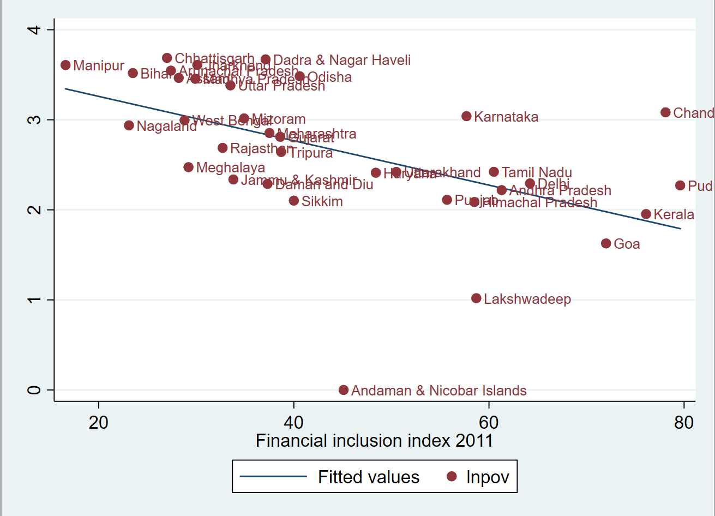

**Fig 4:** *Fitted value graph of lnpov vs financial inclusion index 2011*

From the above quantitative analysis, we have found a general correlation of poverty with the financial inclusion in the states. As we plot the fitted values, we observe that even though there is strong correlation, the effect on the individual states vary greatly from each other. Therefore, we also look into the critical parameters involved in the calculation of the financial inclusion index (CRISIL Inclusix). We present below the financial inclusion across each parameter separately and according to the overall analysis, we observe that credit penetration is the differentiating factor for the states that have low financial index. So, in the next section, we discuss these parameters with the respect to the current Indian policy for financial inclusion, that is, PMJDY.

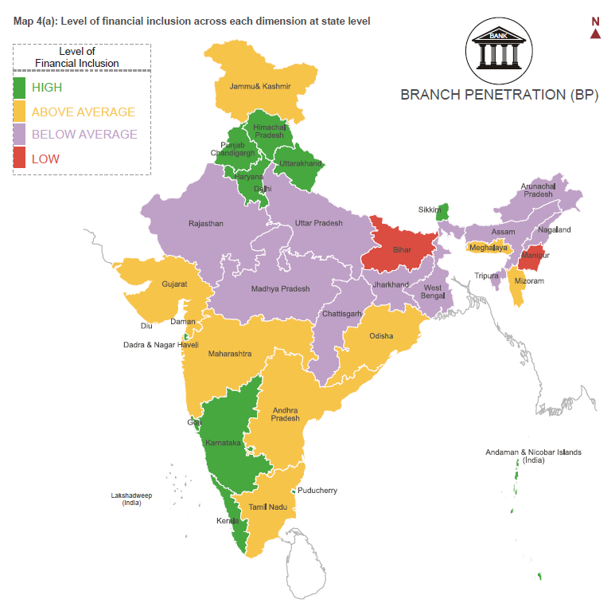

**Fig 5:** *State-wise level of financial inclusion with respect to branch penetration*

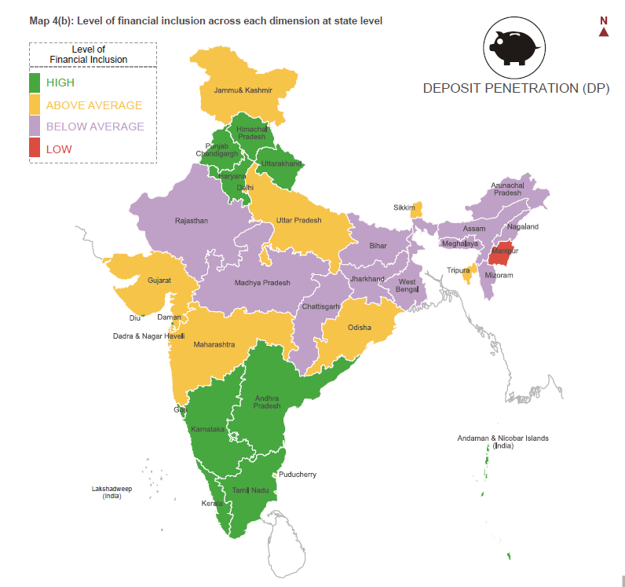

**Fig 6:** *State-wise level of financial inclusion with respect to deposit penetration*

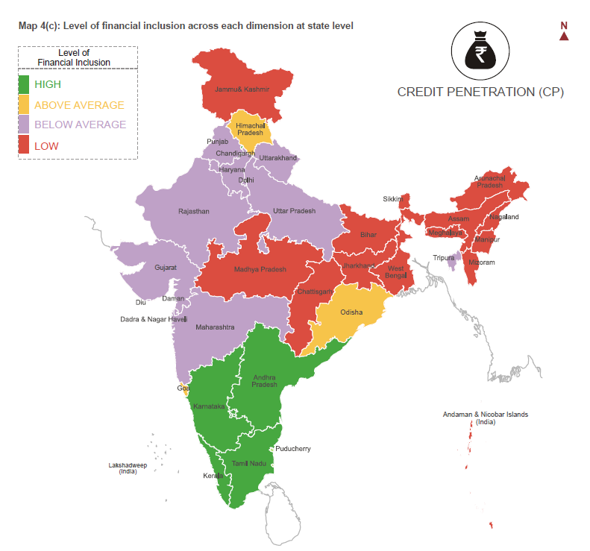

**Fig 7:** *State-wise level of financial inclusion with respect to credit penetration*

# Progress post PMJDY and implications on poverty

This section briefly discusses the growth in financial inclusion and the impact of PMJDY. The performance on various metrics helps to understand how it affects poverty.

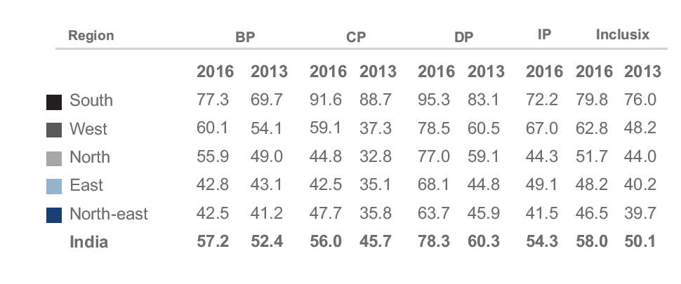

**Fig 8:** *Region wise score of inclusion parameters (CRISIL Inclusix, Feb 2018, Vol 4)*

## Deposit Penetration

Post PMJDY, the performance on deposit penetration has substantially improved. Deposit accounts registered a compound annual growth rate (CAGR) of 16% between fiscal 2013 and fiscal 2016 - 60 crore new deposit accounts were opened during this period, which is twice the number of new deposit accounts opened between fiscal 2010 and fiscal 2013. Jan- Dhan Yojana was the prime driver for high growth in deposit accounts - half of 42 crore new deposit accounts opened between fiscal 2015 and fiscal 2016 were under Jan-Dhan Yojana. Deposit accounts are a necessary prerequisite to access the financial system. The increase in growth means poor people get access to better savings options and access products like insurance. The government also plans to provide subsidies directly to bank accounts to avoid leakages and a large increase in bank accounts is necessary to ensure poor get the complete benefit of these schemes.

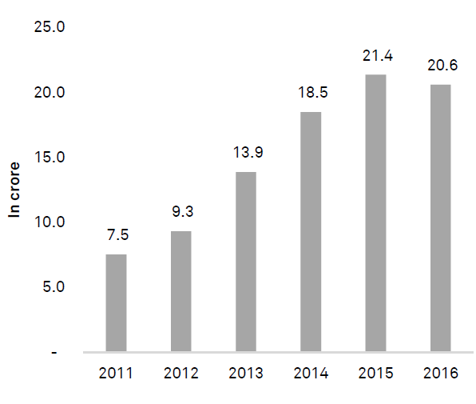

**Fig 9:** *Yearly growth in deposit accounts (CRISIL Inclusix, Feb 2018, Vol 4)*

## Improvement in Credit Penetration

The widest regional disparity in credit penetration scores continues with the south being way ahead of other regions. This indicates the prevalence of credit culture in the south through formal channels. Due to increasing the presence of microfinance institutions (MFI), the east and the north-east have also shown remarkable improvement in the recent past. The low number of credit accounts in comparison to deposit accounts reflect the underperformance on this parameter. Substantial growth in credit accounts in west, east and north-east mean that improvement is taking place. Focussed policy in the north to extend formal credit should be looked into. Credit is a persistent issue for the poor as they lack collateral, proper documentation etc. Access to formal credit channels gives them loans at lower interest rates. The underperformance on this metric in backward regions leads to a situation where poor get loans at high interest rates and rich get them at low interest rates.

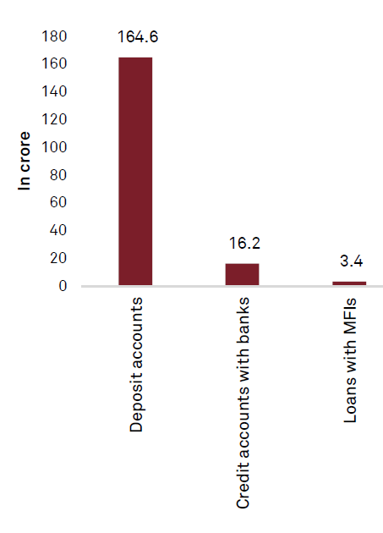

**Fig 10:** *Number of accounts by type (CRISIL Inclusix, Feb 2018, Vol 4)*

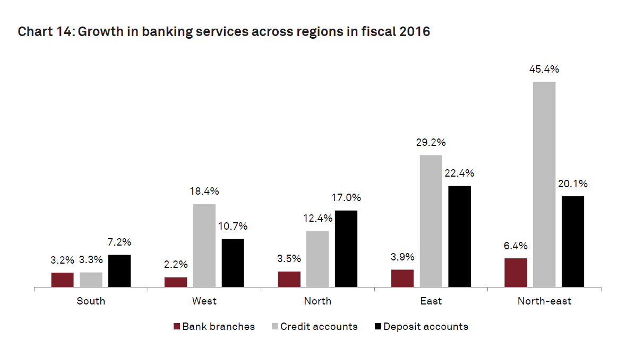

**Fig 11:** *Growth in banking service across regions in fiscal 2016 (CRISIL Inclusix, Feb 2018, Vol 4)*

## Improvement in Branch Penetration

Bank branches showed progress between fiscal 2013 and fiscal 2016, albeit at a modest CAGR of 7%. The number of new bank branches opened in fiscal 2016 was the lowest in the past six years. With increasing penetration of mobile phones, the idea of branchless banking is gaining popularity, resulting in moderate growth of bank branches. Microfinance branches registered a modest CAGR of 5% between fiscal 2013 and fiscal 2016. Physical accessibility to banks is essential to the poor as they lack mobile, stable network or the required know-how. They may not be financially aware and may need help from bank staff to access their account. These issues exacerbate for women as they are not allowed to go long distances. Thus they become dependent on men to access their finances. A push for expansion of bank branches is the need of the hour.

# 

**Fig 12:** *Growth in MFI Branches* **Fig 13*:*** *Growth in bank branches*

The improvement in Inclusix could be much faster with increased focus on enhancing branch and credit penetration beyond the south. Branch and credit penetration is currently highly focused in the south and large cities, and needs to be expanded to other regions. Tailwinds from policy steps such as differentiated banking licences are expected to expand branch and credit services in other regions, and boost financial inclusion over the medium term. However, policy makers will have to continue to incentivise expansion of branch and credit in districts with low CRISIL Inclusix score to hasten financial inclusion across the country.

# Conclusion

Our study proves that financial inclusion is an important factor in our fight against poverty. Despite the overwhelming evidence to increase financial inclusion, financial inclusion remains low to average in many regions according to the latest 2016 scores by CRISIL. Even other similar studies show similar results. According to Yadav, et al, The value of the financial inclusion index appears to reflect a modest increase in the degree of financial inclusion across districts from 2011–2018. The mean FII value rose from 0.121 in 2011 to 0.146 in 2018, with most central, eastern, and north-eastern districts doing poorly in financial inclusion and being under low financial inclusion. While the PMJDY is a step in the right direction and has led to substantial gains in financial inclusion, the policy needs to shift to improving other aspects of financial inclusion like credit, insurance etc. The push needs to have regional-level objectives and policy to ensure all regions have equal access to financial services. Government needs to look for more non-traditional methods to increase spread such as microfinance institutions and develop regulations that welcome such institutions. This would help to increase financial inclusion at the aggregate level but also improve access of the most underprivileged in the society.

short dash

# Appendix

Why Urban GINI was not added? As we can see in the below presented table, the coefficient of the urban GINI coefficient is highly insignificant.

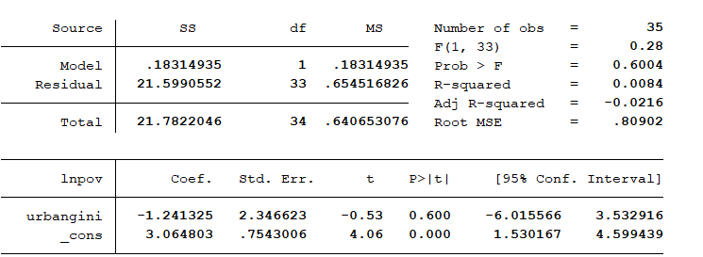

1. Fernanda Doz Costa, "Poverty and human rights from rhetoric to legal obligations", SUR 9 (2008), accessed February 26, 2021, https://sur.conectas.org/en/poverty-human-rights-rhetoric-legal-obligations/
2. Maddison, A. (1970). The historical origins of Indian poverty. *Quarterly review / Banca Nazionale del Lavoro, Roma, 92*, .
3. Swamy, V. (2014). Financial inclusion, gender dimension, and economic impact on poor households. World development, 56, 1-15.
4. Burgess, Robin, and Rohini Pande. 2005. "Do Rural Banks Matter? Evidence from the Indian Social Banking Experiment." *American Economic Review*, 95 (3): 780-795.
5. Brune, Lasse and Gine, Xavier and Goldberg, Jessica and Yang, Dean, Commitments to Save: A Field Experiment in Rural Malawi (August 1, 2011). World Bank Policy Research Working Paper No. 5748, Available at SSRN: <https://ssrn.com/abstract=1904244>
6. https://www.rbi.org.in/scripts/PublicationsView.aspx?id=16603
7. https://www.crisil.com/content/dam/crisil/our-analysis/publications/crisil-inclusix/CRISIL-Inclusix-An-index-to-measure-indias-progress-on-financial-inclusion-vol1-june2013.pdf
8. https://www.esopb.gov.in/Static/PDF/GSDP/Statewise-Data/StateWiseData.pdf
9. ttps://niti.gov.in/planningcommission.gov.in/docs/data/datatable/data_2312/DatabookDec2014%20106.pdf
10. https://www.education.gov.in/sites/upload_files/mhrd/files/statistics-new/ESAG-2018.pdf
11. <https://rbi.org.in/Scripts/PublicationsView.aspx?id=20142>

    https://www.mha.gov.in/zonal-council